seamanship

SM02

General Ropework

reef knot, figure of eight, round-turn-and-two-half-hitches

Reference Material

|  |  |
| --- | --- |
| Rope | Suitable rope and spars for cadets to practice |
| Handbook | Bends and Hitches Handbook |
| Games (optional) | Games |
| Video (optional) | Videos, laptop, projector, screen |

|  |  |  |
| --- | --- | --- |
| SCC_SM02_SP_Bends_V00.00 | | |
| V00.00 | 08/10/16 | Initial draft |

## Elements / Basic Terms

As a cadet and during your training you will be required to know how to secure boats using the correct bends and hitches.

There are **twelve** (12) basic terms that Cadets will be required to know.

All knots, bends and hitches reduce the strength of a rope from 40%-60% and you should consider this factor before putting any load on them.

## Bends and Hitches

1. **A bend** is a method of temporarily joining to ropes.
2. **A hitch** is a method of temporarily joining a rope to a ring, post or rail (like a rope to an anchor).
3. **A knot** is the intertwining of strands of smaller rope or ropes to prevent a rope un-reeving or to provide handhold, weight or a stopper on any part of the rope.

These definitions have become blurred with time and all three terms are now used interchangeably.

Commonly used bends and hitches are described here and knots and their uses are described in the core seamanship sessions.

|  |  |  |  |  |
| --- | --- | --- | --- | --- |
| 1. **Bight** | 1. **Twist** | 1. **Round turn** | 1. **Half hitch** | 1. **Overhand knot** |
| A bight is a bend between the ends of a rope  It also means the middle part of a length of rope | A bight that has been twisted in the rope. | A **turn** or **single turn** is a curve with crossed legs.  A **round-turn** is the complete encirclement of an object; requires two passes.  **Two-round-turns** circles the object twice; requires three passes. | Tied with one end of a rope being passes around an object and secured to its own standing part with a single hitch. | Mainly used as an element of a larger knot – it may be used on its own as a stopper on the end of a rope to prevent it un-laying. |
| Image result for twist rope | Image result for twist rope | https://upload.wikimedia.org/wikipedia/commons/thumb/d/d1/Eyes_and_turns.jpg/220px-Eyes_and_turns.jpg | Image result for half hitch |  |

|  |  |
| --- | --- |
| 1. **Standing Part** – The part of a rope which is nearest the eye, bend or hitch and not available for use 2. **Working Part** – The short length of a rope which may be formed into an eye, making a bend or hitch. 3. **The Rope End** – also the length which is left over after making the eye or bend 4. **The Bitter End or Fag End** – The extreme end of a length of rope | File:BightLoopElbow.jpg |

## Sea Cadet 7 Terms

Seamanship SM02 talks about **seven** (7) terms, these are:

* **A bend** is a method of temporarily joining to ropes.
* **A hitch** is a method of temporarily joining a rope to a ring, post or rail (like a rope to an anchor).
* **A knot** is the intertwining of strands of smaller rope or ropes to prevent a rope un-reeving or to provide handhold, weight or a stopper on any part of the rope.
* **Standing Part** – The part of a rope which is nearest the eye, bend or hitch and not available for use
* **Working Part** – The short length of a rope which may be formed into an eye, making a bend or hitch.
* **The Rope End** – also the length which is left over after making the eye or bend
* **The Bitter End or Fag End** – The extreme end of a length of rope

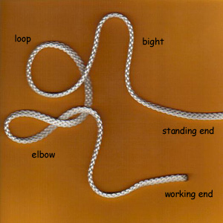

Standing End

Working End

Bitter End

Fag End

Working Part

Standing Part

Twist

Bight

Loop

## Overhand knot

Mainly used as an **element for larger knots**. It may also be used on its own as a **basic stopper** knot.

As a stopper knot it can bind and is smaller than a figure of eight knot. A figure of eight knot is preferred.

|  |  |
| --- | --- |
| Positive | Negative |
| Once learnt is the basis of many knots. | As a stopper knot it can bind and is smaller than a figure of eight knot. A figure of eight knot is preferred.  Once under pressure can be difficult to untie. To untie push both ends of the rope closer together, then untie If under significant strain then you may need to pull at the edges of the knot to loosen it, or wriggle the end of the rope but expect that you may need to cut the knot out. |

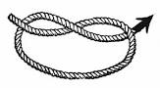

This is a very simple knot created by forming a loop and passing the working end around the standing part and through the loop.

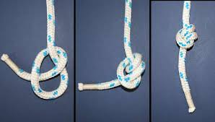

Some people use the double-overhand knot as a knot between the overhand knot and the figure of eight. A figure of eight would be the preference.

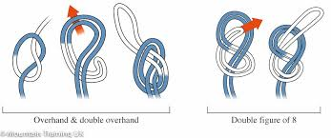

Alternatively, to add weight and make it a bit easier to untie, tie the knot on a bend.

## Figure of eight

This is a stopper knot to **stop** ropes from unreeving through an eye or block. This is a very important boating knot. It is better than an overhand knot being of larger size and easier to undo.

This knot is sometimes referred to as a *Flemish knot.*

|  |  |
| --- | --- |
| Positive | Negative |
| Can be more easily undone than an overhand knot by breaking the back of the knot – pushing one of the loops along the length of the working end that passes through it.  Forms a larger stopper than an overhand knot.  One of the strongest form of knots. Forms a secure non-slip knot at the end of a rope. |  |

Whilst the knot shown here is a single figure of eight it can also be tied by starting with a bight and then tying a figure of eight (second image) so that the knot is largeror on a bight so it forms a double thickness knot (third image also called “bunny ears”).

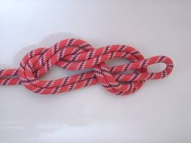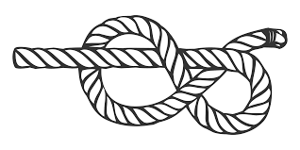

## Reef

This is used to **join two pieces of rope of equal thickness** - it is one of the most unreliable and insecure knots that we tie.

If tied wrong it can be a real problem.

|  |  |
| --- | --- |
| Positive | Negative |
| It can be collapsed easily by pulling apart the standing part and working end of the same length of cordage. | If you make a mistake when tying a Reef Knot, you could end up tying either a granny knot or a thief knot |

The correct knot should be easily recognisable – both long ends (standing parts) opposite each other and both working ends (short ends) opposite each other – and both sides symmetrical.

The basic knot is tied on using right over left and under, left over right and under. This means that both working parts (short) and bot stading aprts (long) are opposite each other. Additionally, the knot is symetrical the red lines (standing and working) ae eith both over or both under the other line (blue):

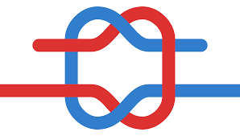

EQUAL THICKNESS

LINES

## Getting it wong:

|  |  |  |
| --- | --- | --- |
| **Thief knot**  Long (standing part) and short (working part) are opposite each other so that the red working is opposite blue standing and visa versa. The knot is symmetrical with both red working and standing over or under the blue bight. | **Granny knot**  Whilst the short (working part) and long (standing part) are correctly positioned opposite each other the knot is not symmetrical – red is under/over rather than both parts being under or both parts being under | Grief knot  The long (standing parts) and working parts (short) are opposite each other as should be but the overall knot is not symmetrical – both red working and standing parts are not over or under the blue bight. |
| https://upload.wikimedia.org/wikipedia/commons/thumb/d/d7/Thief_knot.svg/120px-Thief_knot.svg.png | https://upload.wikimedia.org/wikipedia/commons/thumb/d/d6/Granny_knot.svg/120px-Granny_knot.svg.png | https://upload.wikimedia.org/wikipedia/commons/thumb/1/16/Grief_knot.svg/120px-Grief_knot.svg.png |

## Round turn and two-half hitches

A Round Turn and two Half Hitches is used to **secure a boat’s mooring line to a jetty post/buoy ring** or another rope - it is made up of two important parts: A Full Round Turn and two Half Hitches.

The name of this knot id given by the parts that it uses.

|  |  |
| --- | --- |
| Positive | Negative |
| To release the knot, pry apart the two hitches with a bending motion. However, it can often be difficult to untie. To help avoid this problem, tie a slipped variation: in the second half-hitch, pass through a bight, |  |

This hitch is formed by:

1. Begin by forming a loop around a pole/spar, with the working end of the rope on top.
2. Bring the working end through the loop. At this point, you have an overhand knot around the pole.
3. Bring the working end down
4. Loop it under the standing end
5. Pull the working end through the loop just formed, tighten, and slide the knot along the standing end up to the post

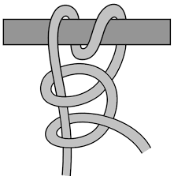

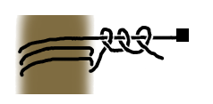

There are variants to this knot, although not often used as the extra elements are not necessary, for example the **Round turn and three half hitches**

Note: often tied to replace a clove hitch especially on fenders as more secure and as quick to tie.

## Demonstration Videos

## Overhand Knot

<http://www.animatedknots.com/overhand/index.php?LogoImage=LogoGrog.png&Website=www.animatedknots.com#ScrollPoint>



## Reef Knot

<http://www.animatedknots.com/reef/index.php?LogoImage=LogoGrog.png&Website=www.animatedknots.com#ScrollPoint>



## Figure of Eight

<http://www.animatedknots.com/fig8_/index.php?LogoImage=LogoGrog.png&Website=www.animatedknots.com#ScrollPoint>



## Round turn and two half hitches

<http://www.animatedknots.com/roundturn/index.php?LogoImage=LogoGrog.png&Website=www.animatedknots.com#ScrollPoint>

