seamanship

SM07

bends and hitches

bowline and running bowline

Reference Material

|  |  |
| --- | --- |
| Rope | Suitable rope for cadets to practice tying |
| Hanbok | Bends and Hitches Handbook |
| Video (optional) | Embedded video, laptop, screen and projector |
| Games (optional) | Games |

|  |  |  |
| --- | --- | --- |
| SCC_SM07_SP_Bends_V00.00 | | |
| V00.00 | 08/10/16 | Initial draft |

## pElements / Basic Terms

As a cadet and during your training you will be required to know how to secure boats using the correct bends and hitches.

There are **twelve** (12) basic terms that Cadets will be required to know.

All knots, bends and hitches reduce the strength of a rope from 40%-60% and you should consider this factor before putting any load on them.

## Bends and Hitches

1. **A bend** is a method of temporarily joining to ropes.
2. **A hitch** is a method of temporarily joining a rope to a ring, post or rail (like a rope to an anchor).
3. **A knot** is the intertwining of strands of smaller rope or ropes to prevent a rope un-reeving or to provide handhold, weight or a stopper on any part of the rope.

These definitions have become blurred with time and all three terms are now used interchangeably.

Commonly used bends and hitches are described here and knots and their uses are described in the core seamanship sessions.

|  |  |  |  |  |
| --- | --- | --- | --- | --- |
| 1. **Bight** | 1. **Twist** | 1. **Round turn** | 1. **Half hitch** | 1. **Overhand knot** |
| A bight is a bend between the ends of a rope  It also means the middle part of a length of rope | A bight that has been twisted in the rope. | A **turn** or **single turn** is a curve with crossed legs.  A **round-turn** is the complete encirclement of an object; requires two passes.  **Two-round-turns** circles the object twice; requires three passes. | Tied with one end of a rope being passes around an object and secured to its own standing part with a single hitch. | Mainly used as an element of a larger knot – it may be used on its own as a stopper on the end of a rope to prevent it un-laying. |
| Image result for twist rope | Image result for twist rope | https://upload.wikimedia.org/wikipedia/commons/thumb/d/d1/Eyes_and_turns.jpg/220px-Eyes_and_turns.jpg | Image result for half hitch |  |

|  |  |
| --- | --- |
| 1. **Standing Part** – The part of a rope which is nearest the eye, bend or hitch and not available for use 2. **Working Part** – The short length of a rope which may be formed into an eye, making a bend or hitch. 3. **The Rope End** – also the length which is left over after making the eye or bend 4. **The Bitter End or Fag End** – The extreme end of a length of rope | File:BightLoopElbow.jpg |

## Bowline

Used for making a temporary loop (eye) at the **end** of a line.

Often used as a rescue line knot or as an *anchor* looping around an object

This is one of the most useful hitches.

|  |  |
| --- | --- |
| Positive | Negative |
| It is very simple to untie this hitch once the eye has been pulled tight:   * You can put pressure on the back of the loop of the Bowline and push the loop against the standing part * This loosens the Bowline - this is called breaking the Bowline Back   It is estimated that this hitch retains around 60% of the ropes strength. | It is estimated that this hitch retains around 60% of the ropes strength.  The hitch can be frustrating to tie – this is often caused by the initial loop being twisted in the counter direction to the route the working end takes |

The size of the temporary loop (eye) you wants determine the length of rope that you require. The steps are:

1. Make a loop in the standing part of rope (this **must** be an overhand loop)
   * If right handed, lay the rope across your left hand – working end towards you
   * Pinch the rope, in the centre of your palm, with your right hand
   * Twist clockwise to form the loop
2. Pass the working end through the loop in the standing part of the rope
3. Pull the working end through
4. Pass the working end around the back of the standing part, ensuring the size of the temporary loop (eye) is the right size
5. Pass the working end back through the original loop at the first stage
6. Pull the standing end (*) with one hand and the two parts of the working end (**)

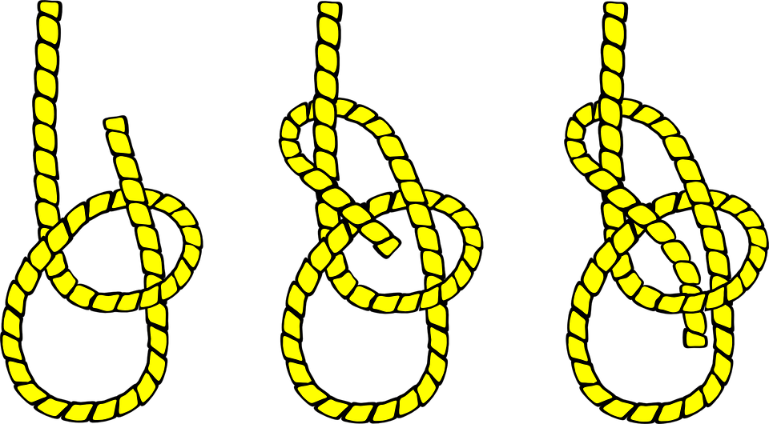

*

**

**

## Bowline, on a bight (not required for the module)

Used for making a temporary loop (eye) at the centre of a line.

Often used as a rescue line hitch, with the extra line reducing cutting in or one loop can be used under the arms and the other under the knees.

|  |  |
| --- | --- |
| Positive | Negative |
| It is very simple to untie this hitch once the eye has been pulled tight:   * You can put pressure on the back of the loop of the Bowline and push the loop against the standing part * This loosens the Bowline - this is called breaking the Bowline Back   It is estimated that this hitch retains around 60% of the ropes strength. | The hitch can slip if only one loop is carry weight. The hitch is best used if each loop is carrying the same weight. |

The size of the temporary loop (eye) you wants determine the length of rope that you require. Using a night:

1. Make a loop in the standing part of rope (this **must** be an overhand loop)
   * If right handed, lay the rope across your left hand – working end towards you
   * Pinch the rope, in the centre of your palm, with your right hand
   * Twist clockwise to form the loop
2. Pass the working end through the loop in the standing part of the rope
3. Pull the working end through
4. This now differs from a standard bowline
   * Using the initial bend pass it over the whole hitch
   * When tightened, the original bight will embrace the original standing ends

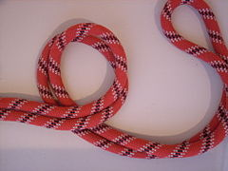 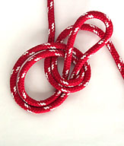 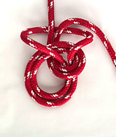 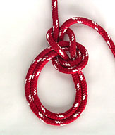

## Bowline, running

Use to make a temporary running loop (eye). With load applied it will tighten and therefore should never be put around any part of a body (strangulation may occur). The temporary loop (eye) can run easily and the hitch can be undone easily even if it has been under strain.

|  |  |
| --- | --- |
| Positive | Negative |
| It is very simple to untie this hitch once the eye has been pulled tight:   * You can put pressure on the back of the loop of the Bowline and push the loop against the standing part * This loosens the Bowline - this is called breaking the Bowline Back   It is estimated that this hitch retains around 60% of the ropes strength. | With load applied it will tighten and therefore should never be put around any part of a body (strangulation may occur).  The working end should be kept short to avoid it getting caught and jamming the free running of this hitch. |

The size of the temporary loop (eye) will normally be small as it is designed to pass around and slide along the standing part of the rope.

A basic bowline is tied (see page 5) **but** the initial bend, before making the overhand loop, is taken around the standing part of the rope.

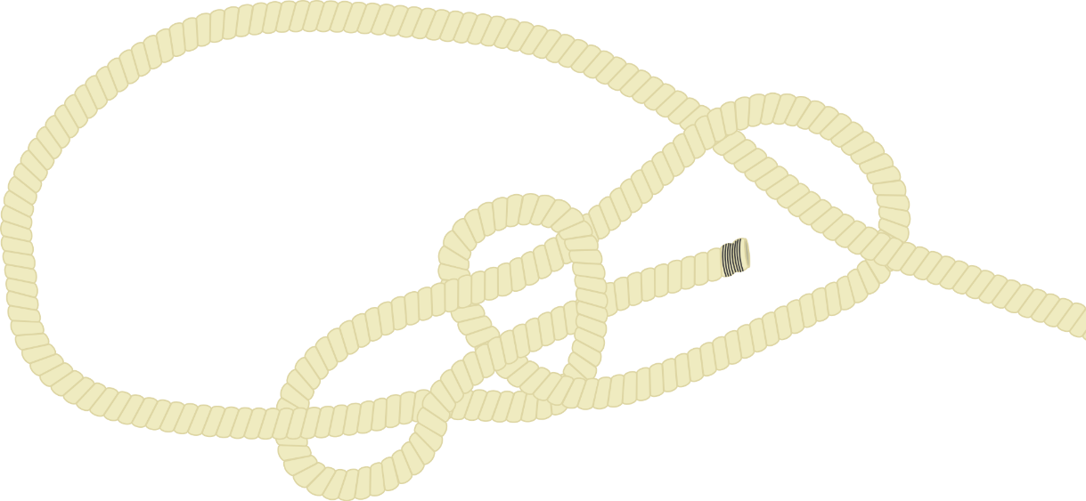The bowline will be able to slide along the standing part of the rope.

## Bowline

<http://www.animatedknots.com/bowline/index.php?LogoImage=LogoGrog.png&Website=www.animatedknots.com#ScrollPoint>



## Bowline, running

<http://www.animatedknots.com/bowlinerunning/index.php?LogoImage=LogoGrog.png&Website=www.animatedknots.com#ScrollPoint>



## Bowline, on a bight (not required for this module)

<http://www.animatedknots.com/bowlinebight/index.php?LogoImage=LogoGrog.png&Website=www.animatedknots.com#ScrollPoint>

