seamanship

SM06

bends and hitches

Sheet bend, double sheet bend, clove hitch, rolling hitch

Reference Material

|  |  |
| --- | --- |
| Rope | Suitable ropes and spar for cadets to practice tying |
| Hanbok | Bends and Hitches Handbook |
| Video (optional) | Videos, laptop, screen and projector |
| Games (optional) | Games |

|  |  |  |
| --- | --- | --- |
| SCC_SM06_SP_Bends_V00.00 | | |
| V00.00 | 08/10/16 | Initial draft |

## Elements / Basic Terms

As a cadet and during your training you will be required to know how to secure boats using the correct bends and hitches.

There are **twelve** (12) basic terms that Cadets will be required to know.

All knots, bends and hitches reduce the strength of a rope from 40%-60% and you should consider this factor before putting any load on them.

## Bends and Hitches

1. **A bend** is a method of temporarily joining to ropes.
2. **A hitch** is a method of temporarily joining a rope to a ring, post or rail (like a rope to an anchor).
3. **A knot** is the intertwining of strands of smaller rope or ropes to prevent a rope un-reeving or to provide handhold, weight or a stopper on any part of the rope.

These definitions have become blurred with time and all three terms are now used interchangeably.

Commonly used bends and hitches are described here and knots and their uses are described in the core seamanship sessions.

|  |  |  |  |  |
| --- | --- | --- | --- | --- |
| 1. **Bight** | 1. **Twist** | 1. **Round turn** | 1. **Half hitch** | 1. **Overhand knot** |
| A bight is a bend between the ends of a rope  It also means the middle part of a length of rope | A bight that has been twisted in the rope. | A **turn** or **single turn** is a curve with crossed legs.  A **round-turn** is the complete encirclement of an object; requires two passes.  **Two-round-turns** circles the object twice; requires three passes. | Tied with one end of a rope being passes around an object and secured to its own standing part with a single hitch. | Mainly used as an element of a larger knot – it may be used on its own as a stopper on the end of a rope to prevent it un-laying. |
| Image result for twist rope | Image result for twist rope | https://upload.wikimedia.org/wikipedia/commons/thumb/d/d1/Eyes_and_turns.jpg/220px-Eyes_and_turns.jpg | Image result for half hitch |  |

|  |  |
| --- | --- |
| 1. **Standing Part** – The part of a rope which is nearest the eye, bend or hitch and not available for use 2. **Working Part** – The short length of a rope which may be formed into an eye, making a bend or hitch. 3. **The Rope End** – also the length which is left over after making the eye or bend 4. **The Bitter End or Fag End** – The extreme end of a length of rope | File:BightLoopElbow.jpg |

## Sheet bend

Used to **join two ropes of unequal size or for securing a rope to a hard eye** - it is simple and quick to tie and as a single bend it will remain secure as long as the pressure remains constant.

Can be used to join a rope to an eye.

|  |  |
| --- | --- |
| Positive | Negative |
| Used to join, temporarily, two ropes / lines of **unequal** thickness.  Quick and simple to tie and will remain secure whilst under constant pressure.  One of the fastest methods of joining ropes / lines.  The greater the load on the knot, the greater the jamming action. | Can come loose / work free if **not** under constant pressure. |

It is recommended that when used as a permanent fixture the bitter ends are seized (bound by small wrappings) – brings the working and standing parts together.

The bend starts with a bend or eye, forming an open bight.

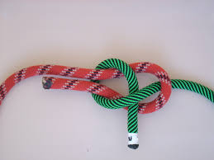The second working end is threaded through the bight (loop), around the back of the first rope/line working and standing ends and back under itself.

If tied correctly both working ends and both standing ends will be opposite each other. The correct bend is created when the second working end passes first behind the working end of the second line and the standing end.

It is possible to add extra strength by tying a Double Sheet Bend (see page 6):

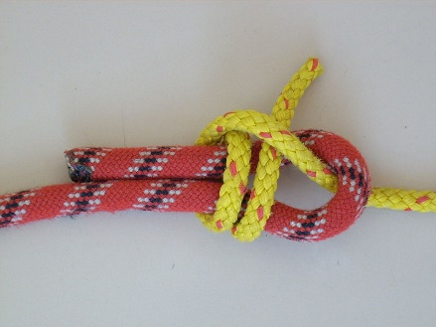

*If tied correctly both working ends and both standing ends will be opposite each other. The correct bend is created when the second working end passes first behind the working end of the second line and the standing end*

## Sheet bend, double

Used to **join two ropes of unequal size or for securing a rope to a hard eye** - it is simple and quick to tie and as a single bend it will remain secure as long as the pressure remains constant. This is used when the difference in thickness between ropes is larger.

Can be used to join a rope to an eye.

|  |  |
| --- | --- |
| Positive | Negative |
| Used to join, temporarily, two ropes / lines of **unequal** thickness.  Quick and simple to tie and will remain secure whilst under constant pressure.  One of the fastest methods of joining ropes / lines.  The greater the load on the knot, the greater the jamming action. | Can come lose / work free if **not** under constant pressure. |

It is recommended that when used as a permanent fixture the bitter ends are seized (bound by small wrappings) – brings the working and standing parts together.

The bend starts with a bend or eye, forming an open bight.

The second working end is threaded through the bight (loop), around the back of the first rope/line working and standing ends and back under itself.

This loop is duplicated, creating a second turn around the fixture.

This second half hitch creates additional strength.

*If tied correctly both working ends and both standing ends will be opposite each other. The correct bend is created when the second working end passes first behind the working end of the second line and the standing end.*

## Clove hitch

Used to **secure a rope, temporally, to a spar/rail or similar fitting**. It is one of the more important hitches to know.

Sometimes called a Peg Knot or Boatman’s knot. Often used in *pioneering* to start and/or finish a lashing.

|  |  |
| --- | --- |
| Positive | Negative |
| The hitch easily allows the length of the running line (working part) to be adjusted, since feeding the working end into the hitch will lengthen the working part.  Works well on around objects, but less well on object with sharp corners (e.g. square or rectangular posts). | This hitch is not secure and can clip if there is intermittent load or inconsistent angles. This hitch should be replaced by a more stable one when/where possible. Alternatively, a stopper knot could be added to the working end once the hitch has been completed.  The hitch can also slip if used with some types of rope or if wet. |

A clove hitch is two half-hitches tied to each other, around an object, and crossing the standing parts.

To tie a clove hitch:

1. Take a turn around the object (wrap) with the working end
2. Cross over itself taking another turn (wrap) around the object
3. Slip the working end under the last wrap
4. 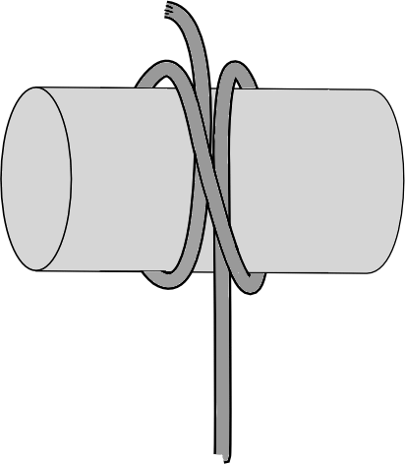Pull working end to tighten sliding turns together

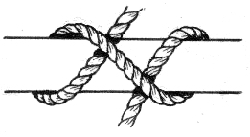

C

B

A

D ->

<- D

## Rolling hitch

Used to **secure a rope to another rope or spar where there is strain on either side**. The hitch is designed to prevent slipping. Very similar to a clove hitch, but more secure than a clove itch. It can withstand constant tension being applied and released. It can be tied and untied under load (one of very few than can). Does not bin. A clove hitch with an extra twist.

|  |  |
| --- | --- |
| Positive | Negative |
| Very similar to a clove hitch, but more secure than a clove itch.  It can withstand constant tension being applied and released.  It can be tied and untied under load (one of very few than can). Does not bin. | Often seen as a stopper knot, to relax the tension on a sheet (rope), so that a jammed winch or block can be cleared |

The rolling hitch is sometimes called a Magnus Hitch and is used to attach a rope/line to a rod, pole or commonly another rope. It is used to pull along the length of the object rather than at right-angle. It is designed to avoid slipping lengthways.

To tie a rolling hitch:

1. Start with a turn around the object. Bring the working end towards the direction of pull and between the standing part and the object.
2. Make another wrap around the object, completing a around turn. The wraps of the round turn should progress towards the desired direction of pull. Bring the working end out over the standing part away from the direction of pull.
3. Complete with a half hitch, moving around the object in the same direction as the first turns, as for a clove hitch.
4. Dress by snugging the hitch around the object before applying load.

A

C

D

B

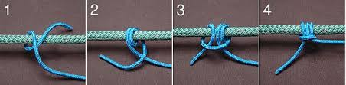

There is a **variant** the is equally acceptable, note the working and standing ends are on different sides of the knot

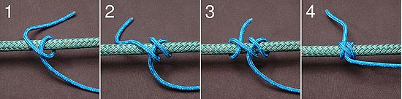

## Sheet Bend and Double Sheet Bend

<http://www.animatedknots.com/sheetbend/index.php?LogoImage=LogoGrog.png&Website=www.animatedknots.com#ScrollPoint>



## Rolling hitch

<http://www.animatedknots.com/rollinghitch/index.php?LogoImage=LogoGrog.png&Website=www.animatedknots.com#ScrollPoint>



## Clove Hitch, using ends

<http://www.animatedknots.com/cloveend/index.php?LogoImage=LogoGrog.png&Website=www.animatedknots.com#ScrollPoint>



## Clove Hitch, using loops

<http://www.animatedknots.com/clove/index.php?LogoImage=LogoGrog.png&Website=www.animatedknots.com#ScrollPoint>

