new entrant

ne06

new entrant

obtain a weather forecast

Reference Material

|  |  |
| --- | --- |
| Forecast | Selection of local weather frecasts |
| Homework | Page  *14* |
| Poster | Page 13 |
| Powerpoint | *CC_TM_P_Wind_Beaufort*  Videos, laptop, projector and screen |

|  |  |  |
| --- | --- | --- |
| SCC_SM03_SP_Bends_V00.00 | | |
| V00.00 | 08/10/16 | Initial draft |

Session plan

|  |  |  |
| --- | --- | --- |
| **Subject** |  | **Obtain a weather forecast** |

|  |  |  |  |
| --- | --- | --- | --- |
| Session plan |  | Ref | SCC_NE06_Weather |
| Course |  | How to obtain a weather forecast [NE06] | |
| Group/Award |  | New entry to cadet | |
| Aim |  | By the end of this session participants will be able to:   * Know that rowing must be carried out under safe weather conditions * List the common sources of weather forecast information from memory * State the maximum wind force levels for rowing/sailing to another cadet with reference materials * Know where to obtain the weather forecast locally * Know and can explain the information given to an instructor | |
| Training format |  | Discussion, research and feedback  *Optional: Presentation of Beaufort Scale sea state images*  *SCC_TM_P_Wind_Beaufort* | |
| Duration |  | 45-minute | |
| References |  | 1. SCC cadet training programme, new entry cadet to cadet session plans (2014 edition), NE06 2. SCC Pulling Guidance Notes 2008 Edition (referenced as 2010 on SCC Website) – Page 5 3. SCC_CW07_TM_Weather   ***Note****: Sources of weather forecast and more detailed application of terms used in forecasts and assessment of risks can be found in Basic Navigation 3rd Class CW07 Weather.* | |
| Training aids |  | * Whiteboard/flipcharts, pens * Paper, pens * Pre-prepared local weather forecast * Local area map (copy) and marker pens * *Optional: Weather diary sheet – see page 14* * *Optional: projector, screen and laptop if SCC_TM_P_Wind_Beaufort is to be used as part of the course* | |
| Notes/Handouts |  | Weather diary sheet – see page *14* | |
| Diversity |  | Check if participants have anything you need to be aware of. | |
| Risk |  | None. | |

Session

|  |  |  |
| --- | --- | --- |
| Pre-course |  | The preceding week to the planned session ask cadets to keep a weather diary as per handout at page 13. This should include one local weather forecast and their own record of the actual weather. They should include their observations on the weather forecast accuracy.  Did all cadets have the same forecasts and actuals – if not can this be put down to recording error or geography (you may want a map and pins to see where they live and if there are any local things that may affect the weather e.g. which side of a hill they live, how high-up they live. |
| Welcome |  | 1-minute Introduction to the session and what is to be covered – overall aim is to give you awareness of weather conditions, terminology and risks. |
| Activity #1 |  | 10-minute On a flipchart/whiteboard write “weather” and discuss what action you may take depending upon the weather |
| Activity #2 |  | 10-minute On a flipchart/whiteboard write “sources” and discuss where you may get weather forecasts from. Try and identify a different range of medium rather than list different websites e.g. internet, periodicals |
| Activity #3 |  | 5-minute Building on the “sources” prepared in the previous Activity (Activity #2), identify those that provide a local weather forecast. Discuss what other local sources there may be depending upon the location for example set a scenario of being in a harbour. |
| Activity #4 |  | 5-minute Discuss when we can go rowing/pulling and introduce the relevant rules  CADET FORCES, TRAINING AFLOAT REGULATIONS AND SAFETY, 2014 EDITION, (SHORT TITLE TARS 14)  Section 903 and 904 |
| Consolidation |  | 5-minute Put up a local weather forecast that has had a few items removed (redacted) and discuss what the missing elements are.  Review and discuss pre-course work |
| Feedback |  |  |
| Lessons Learnt |  |  |

|  |  |  |  |
| --- | --- | --- | --- |
| References |  |  | |
| SCC cadet training programme, new entry cadet to cadet session plans (2014 edition), NE06 | | | |
|  | | |  |
| SCC Pulling Guidance Notes 2008 Edition (referenced as 2010 on SCC Website) – Page 5 | | | |
|  | | | |

# Know that rowing must be carried out under safe weather conditions

## Electrical storm

If there is any likelihood of an electrical storm (thunder storm) you need to consider if you should take to the water or not. If your planned activity is close to a shoreline and it would be easy to come off the water in an electrical storm then it may be safe to continue with the activity, although a careful watch and consideration of changing weather conditions will be necessary. If in doubt, don’t go out!

## Wind and wind-age

Wind-age is the pressure applied to a vessel because of air resistance. For a boat this means the force applied to the area of boat (hull and crew) sticking out of the water. The wind will apply a pressure to the boat. Pulling (rowing) with the wind will appear easy, turning around and pulling against the wind will be hard. You will need to consider the wind direction and the impact on wind-age and effect on time. Rowing downwind for30-minutes could take 60-minutes to pull back to the starting point.

If the wind is blowing from a side, it may be difficult to row in a straight line unless you may a course correction (adjustment) for the wind.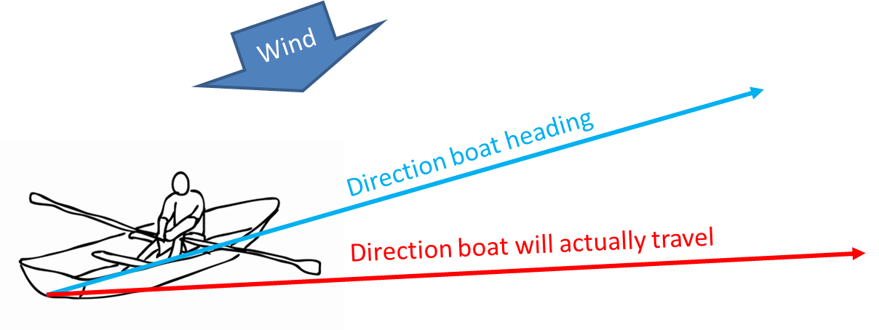

## Warm weather

If the weather is warm and/or hot, then it is important to dress correctly and carry plenty of fluid to avoid the potential hyperthermia (heat-stroke) and to cover up to avoid sun burn.

Potential clothing and equipment includes:

T-shirt (layered clothing that can be easily removed)

Shorts

Tech-top (special top that can wick away sweat)

Sunglasses

Su cream

Water bottle

Cap

## Cold weather

Cold weather needs preparing for as does warm weather to avoid hypothermia and/or frostbite. Clothing and equipment may include:

Splash top / waterproofs

Hat

Long socks

Thermal underwear

Warm drink

High-energy snacks

## Clothing

Care needs to be taken when choosing clothing to ensure you wear layers so you can add/remove to better control temperature, they should not be too losing fitting that they can catch on oars, rowlocks etc. Bulky fleeces and quilted tops absorb water and become heavy in ineffective. Avoid clothes that restrict rowing movement like jeans. Wellingtons that cannot be easily kicked off, without using your hands, present a real danger if you end up falling into the water.

# List the common sources of weather forecast information from memory

Checking the weather forecast before putting to sea is one of our obligations under SOLAS V. It is always advisable to check more than one weather forecast, and take a view across several forecasts as all are prone to estimating error as the weather is never 100% predictable.

The closer a forecast is issued to the time it is covering; the more accurate it is likely to be, a forecast for 3 or 5 days hence is likely to be inaccurate. To get a better forecast you should consider what the forecasters are saying, what the actual weather conditions are and what has already happened. Through these 3 combined factors you should be able to get a more accurate forecast. Using all the combined data should enable you to produce a realistic 4 or 5-day weather prediction.

Forecasts are derived from their source data in different ways e.g. Satellites and radar provide real time data for cloud and rain, but not for wind. Wind data is only available from a weather station, as these are based in specific locations. Forecasters must build computer simulations/models to enable localised wind and weather predictions. These models are often very generic and do not consider specific local anomalies e.g. effects of a headland, or sea breeze which mean that local wind forecasts may need further interpretation by users.

**Sources of weather information often include:**

* Newspapers/Media
* Telephone
* Marie Notice Boards
* Radio
* Voice broadcasts of forecasts
* Radio facsimile need a computer interfaced with the radio.
* Radio teletype.
* Television
* Websites

**Shipping Forecast -** The Shipping forecast is broadcast on Navtex 518 kHz twice a day and by the BBC four times a day on Radio 4. The content of the Radio 4 transmission and the frequency bands used, vary depending on the time of the broadcast (see over)

**NAVTEX** – are low cost dedicated receivers for collectingMarine Safety Information, via text type message. These can enable weather forecasts to be obtained from 250+ miles out to sea and these mini-computer based systems can record the data to be referred too later

**Gale warnings -** are issued by the Met Office when winds in any part of a sea area are expected to reach Force 8 or above and / or if gusts of 43 knots or more are anticipated (excluding gusts in thunderstorms). Warnings are broadcast on Radio 4 and are valid for 24 hours unless cancelled.

**Strong wind warnings -** are issued if winds of force 6 or more are expected that have not already been included in the current inshore waters forecast. Warnings are broadcast on Radio 4 and are valid for 24 hours unless cancelled.

# State the maximum wind force levels for rowing/sailing to another cadet with reference materials

**CADET FORCES, TRAINING AFLOAT REGULATIONS AND SAFETY, 2014 EDITION, (SHORT TITLE TARS 14)**

903. **Weather Conditions**. Rowing is not to take place in winds of over 16 kts and / or wave height more than 0.3m. Units, schools and course officers are to ensure that limiting weather conditions are listed within their SMS / SOPs for each activity giving clear instruction as to when the activity is to be stopped or re-located. Instructors / Supervisors are to source up to date weather forecasts covering the duration of training before the activity starts and monitor throughout.

904. **Rowing Season**. Rowing will normally take place 1 Mar – 30 Oct each year in fair weather and in daylight. Dispensation to operate outside these parameters must be sought from the CF Area or National HQ in writing before any training takes place. Any such dispensation must be lodged with the activity risk assessment.

**TRINITY 500 OWNER’S MANUAL**

**Design Category D:** The Trinity 500 is designed for use in waters of Design Category D, Sheltered Waters; on small lakes, rivers and canals where conditions up to wind force 4 and significant wave heights up to 0.5 m may be experienced.

# Know where to obtain the weather forecast locally

## BBC weather using postcode

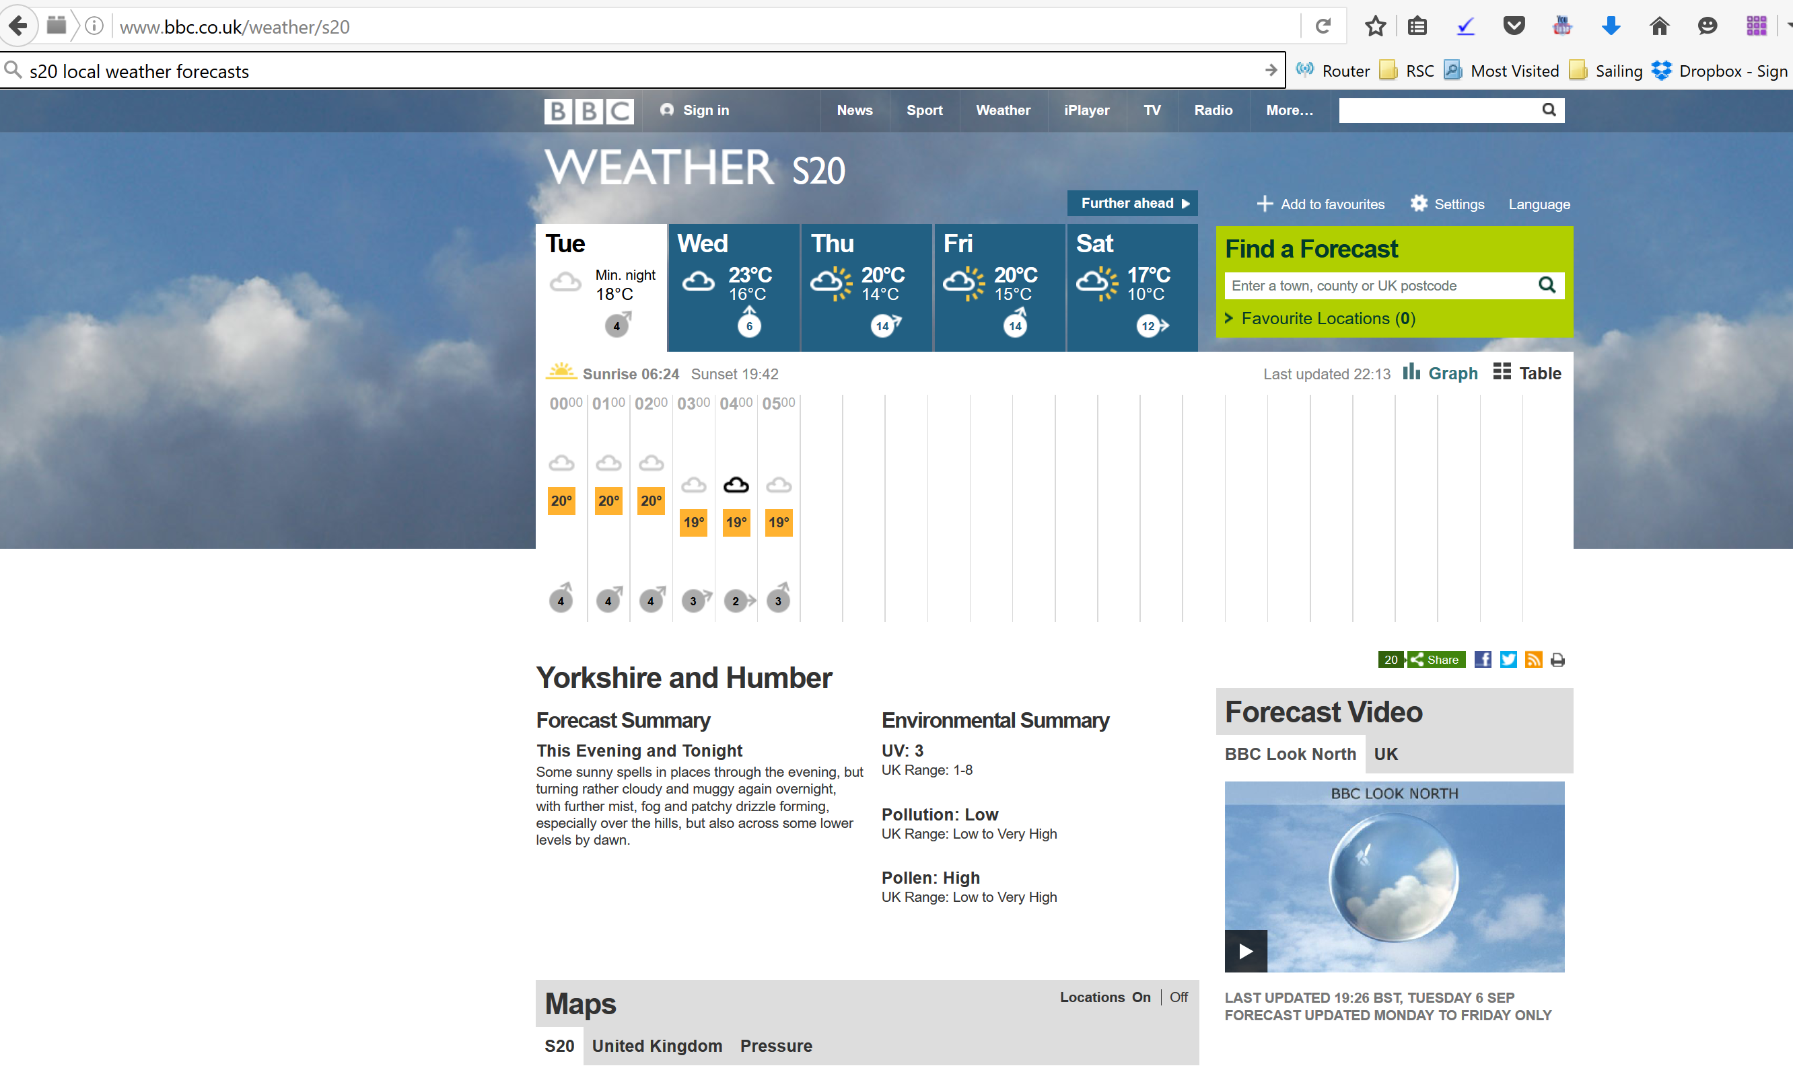

## Windguru Mobile Phone App (and internet)

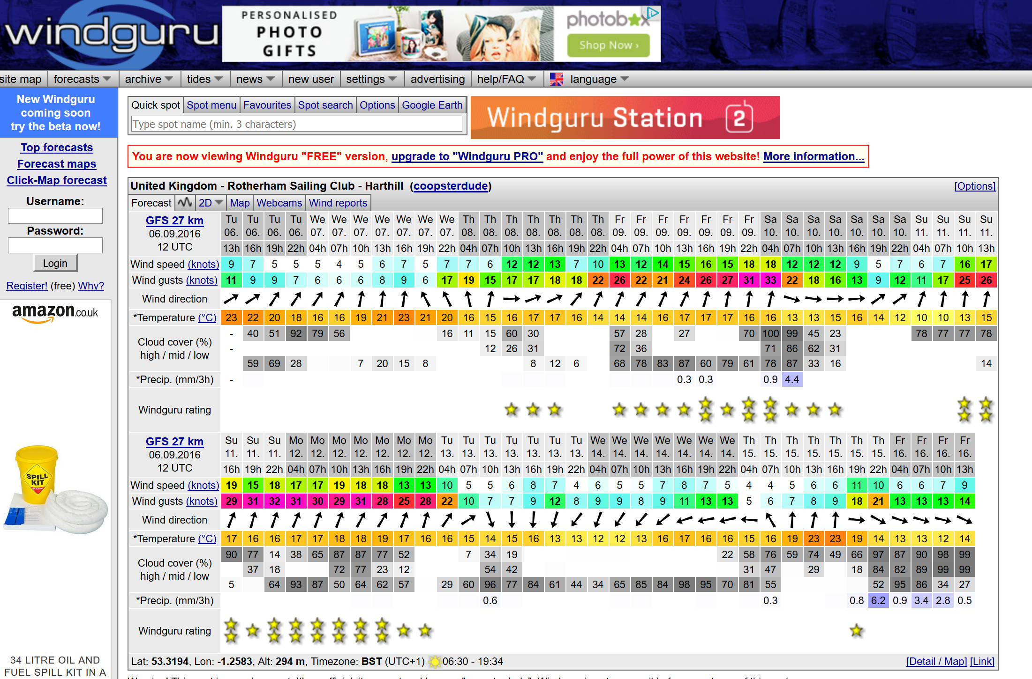

## Local Radio stations

There are a number of local radio stations that can be picked up on a range of radio including mobil phone radios, for example BBC Radio Sheffield and Hallam FM each broadcast regular weather forecasts

## Sheffield boating station

Like most boating centres the Sheffield Sea Cadet boating station will check the weather forcast before allowing activity to take place. The results will be placed on a notice board to see. The Boating Station will take a umber of forecasts and consider how well they match each other before determining what the forecast is liekly to be.

At the coast you will find similar posting in harbours and specifically on the habour masters office.

Other to include e.g. newspaper clipping

# Know and can explain the information given to an instructor

Homework: obtain a local weather forecast and explain the source and what it means to an instructor

Note #01: wind speed

Wind speed is referred to in knots (nautical miles an hour). A **nautical mile** is a unit of measurement defined established by 1’ (one minute of latitude = 1/60 degree of latitude).

This means that a nautical mile is 1852 meters (6,076.12 feet or 1.2 statute miles).

Each degree of latitude = 60 nautical miles, 1 minute = 1 nautical mile and 1 cable = 1/10 nautical mile.

A **cable** is 1/10nm or about 185m.

Until the mid-19th century, vessel speed at sea was measured using a chip-log. The chip log was "cast" over the stern of the boat, with knots places at every 8 fathoms. The sailor would count how many knots were passed out in 3 seconds, working out their speed.

Note #02: Beaufort Scale

The scale was devised in 1805 by Irish-born Francis Beaufort (later Rear Admiral Sir Francis Beaufort), a Royal Navy officer, while serving in HMS Woolwich. The scale that carries Beaufort's name had a long and complex evolution from the previous work of others (including Daniel Defoe). The scale is still used today see pages 10 and 11.

See also

SCC_CW_06_Safety_C_WindBeaufort

SCC_TM_P_Wind_Beaufort_P

# Additional Information

## Some terms you may hear: Beaufort Scale

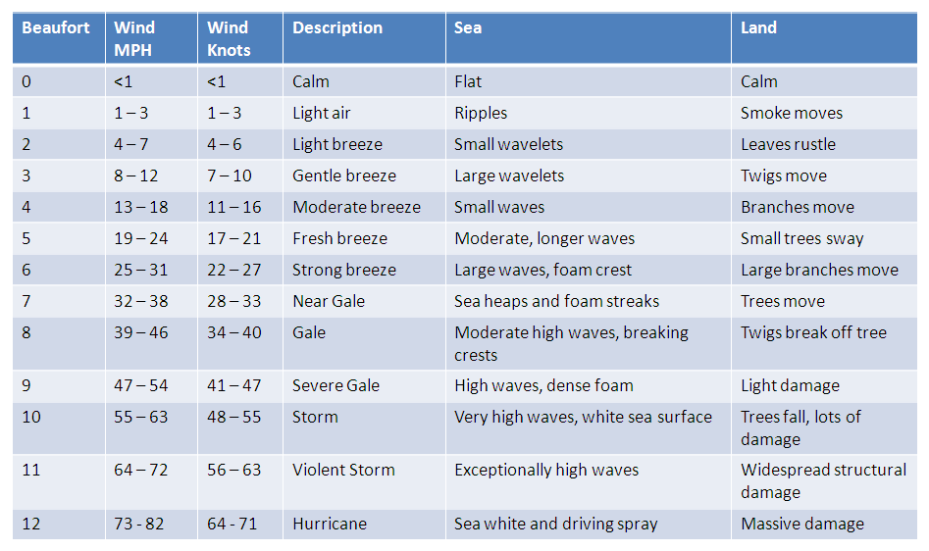The **Beaufort scale** is the empirical measure for the intensity of the wind.

## Terms you may hear on a weather forecast

**Timing, mainly used in gale warnings**

* Imminent Within 6 hours
* Soon Within 6 to 12 hours
* Later More than 12 hours

**Other Terms**

* Fair No significant precipitation
* Backing Wind Wind changing in an anticlockwise direction
* Veering Wind Wind changing in a clockwise direction

**General Synopsis - Overall pattern of major systems**

* Slowly                 0 to 15 knots
* Steadily                15 to 25 knots
* Rather rapidly       25 to 35 knots
* Rapidly                35 to 45 knots
* Very rapidly         45 knots and over

**Visibility definitions**

* Good more than 5 miles.
* Moderate 2 to 5 miles.
* Poor 1,100 yards to 2 miles
* Fog Less than 1,100 yards
* Mist or haze Between 1,100 yards and 2,200 yards.

## Beaufort Scale: alternate versions

|  | Defoe 1704 | Beaufort 1806 | Beaufort 1831 | **Beaufort Current** | Heron Class Association 1970 | Landsman | Unattributed | Dinghy sailor |
| --- | --- | --- | --- | --- | --- | --- | --- | --- |
| 0 | stark calm | Calm | Calm | **Calm** |  | Cigarette smoke get in your eyes | Children want dad to fly kite | Boredom |
| 1 | calm weather | Faint breeze or just not a calm | Light air | **Light air** | Helmsman and crew sit well in board. Boat has very little way on. | Wet finger feels cold | Reading newspaper outside becomes a problem | Boredom |
| 2 | little wind | Light air | Light breeze | **Light breeze** | Helmsman only sits on weather side. | Public house closes one windows | Reading newspaper outside is impossible | Mild pleasure |
| 3 | a fine breeze | Light breeze | Gentle breeze | **Gentle breeze** | Helmsman and crew both sit on weather side. | Public house closes two windows | Twigs by front window tap n glass | Pleasure |
| 4 | a small gale | Gentle breeze | Moderate breeze | **Moderate breeze** | Helmsman and crew both sit out on weather side. | Beer froth blows off | Side gate bangs in the night | Great pleasure |
| 5 | a fresh gale | Moderate breeze | Fresh breeze | **Fresh breeze** | Dinghies must ease sheets in heavier gusts when beating. | Customers in pub garden go inside | Old gentleman’s hat blows away | Delight |
| 6 | a top sail gale | Fresh breeze | Strong breeze | **Strong breeze** | Reefing necessary, even when racing. | Elderly customers have difficulty leaving the pub | Clothes line comes down putt clean clothes in mud | Delight tinged with anxiety |
| 7 | blows fresh | Gentle, steady gale | Moderate gale | **Near gale** | Mainsail reefed below jib head. Boats should not be taken out. | Pub door cannot be opened against the wind | Side gate bangs even if bolted | Anxiety tinged with fear |
| 8 | a hard gale of wind | Moderate gale | Fresh gale | **Gale** | Difficult to sail at all even with jib only. | Pub sign blows down | Car steering seems to have gone wrong | Fear tinged with terror |
| 9 | a fret of wind | Brisk gale | Strong gale | **Strong gale** |  | Dinghy sailor hit by falling pub sign | Old ladies hat blown away | Great terror |
| 10 | a storm | Fresh gale | Whole gale | **Storm** |  |  | Clothes line with new sheets on takes off | Panic |
| 11 | a tempest | Hard gale | Storm | **Violent storm** |  |  | Old ladies and gentlemen blown away |  |
| 12 |  | Hard gale with heavy gusts | Hurricane | **Hurricane** |  |  | Children want Dad to fly new kite |  |
| 13 |  | Storm |  |  |  |  |  |  |

<http://weather.mailasail.com/Franks-Weather/Historical-And-Contemporay-Versions-Of-Beaufort-Scales>

## Poster: Beaufort Scale

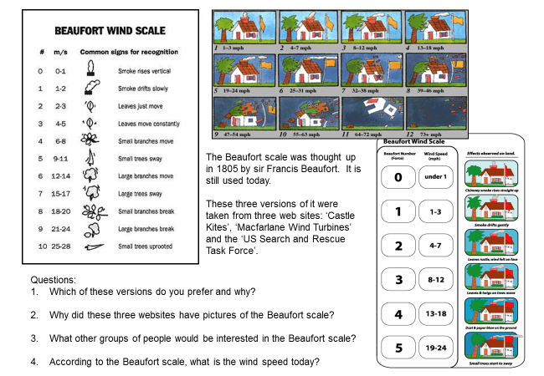

[www.sln.org.uk/geography/Documents/geocreativity/.../7.3%20**beaufort**%20**scales**.**ppt**](http://www.sln.org.uk/geography/Documents/geocreativity/.../7.3%20beaufort%20scales.ppt)

## Handout: weather diary

|  |  |  |  |
| --- | --- | --- | --- |
| Name |  | Weather forecast source | *Insert details of the source of the local weather forecast used* |
|  |

|  |  |  |  |  |  |
| --- | --- | --- | --- | --- | --- |
| Day / Date | 1 | 2 | 3 | 4 | 5 |
| What did the weather forecast say about the local forecast on the day? |  |  |  |  |  |
| **What happened?** | | | | | |
| Wind direction? |  |  |  |  |  |
| Wind strength? |  |  |  |  |  |
| Rain? |  |  |  |  |  |
| Sun? |  |  |  |  |  |
| Cloud? |  |  |  |  |  |
| Temperature? |  |  |  |  |  |
| Pressure? |  |  |  |  |  |
| **Observations?** | | | | | |
| e.g. was the forecast accurate, if not did you find a better forecast? |  |  |  |  |  |