Session plan

Subject |  | IRPCS09: Narrow Channels

Session plan |  | Ref | SCC_Nav_CW06_IRPCS09_Narrow Channels
Course |  | CW06 Narrow Channels [IRPCS09]
Group/Award |  | Basic navigation 3rd Class
Aim |  | To ensure cadets have a working knowledge of IRPCS09 narrow channels
Training format |  | Discussion
Duration |  | 5-minute
References |  | None
Training aids |  | Diagram, page 3, could be replicated on whiteboard to stimulate discussion
Notes/Handouts |  | None
Diversity |  | Ensure visibility of presentation and active engagement in discussions of all cadets. If activity sheet is used, it does not have to be neat – it only needs to be a representation.
Risk |  | None

V00.00 | 18/02/18 | Initial draft

Session
Welcome |  | 1-minute Introduce the session
Activity #1 |  | 5-minute Ask cadets what they would consider a narrow channel to be and why there maybe problems with them (see page 4)
Activity #2
Activity #3
Activity #4
Consolidation |  | 1-minute summarise the discussion
Feedback

Lessons Learnt

a) A vessel proceeding along the course of a narrow channel or fairway shall keep as near to the outer limit or the channel or fairway which lies on her starboard side as is safe and practicable.
(b) A vessel of less than 20 metres in length or a sailing vessel shall not impede the passage of a vessel which can safely navigate only within a narrow channel or fairway.
(c) A vessel engaged in fishing shall not impede the passage of any other vessel navigating within a narrow channel or fairway.
(d) A vessel shall not cross a narrow channel of fairway if such crossing impedes the passage of a vessel which can safely navigate only within such channel or fairway. The latter vessel may use the sound signal prescribed in Rule 34 (d) if in doubt as to the intention of the crossing vessel.
(e)
(i) In a narrow channel or fairway when overtaking can only take place if the vessel to be overtaken has to take action to permit safe passing, the vessel intending to overtake shall indicate her intention by sounding the appropriate signal prescribed in Rule 34 (c) (i). The vessel to be overtaken shall, if in agreement, sound the appropriate signal prescribed by Rule 34 (c) (ii) and take steps to permit safe passing. If in doubt she may sound the signals prescribed in Rule 34 (d).
(ii) This rule does not relieve the overtaking vessel of her obligation under Rule 13.
(f) A vessel nearing a bend or an area of narrow channel or fairway where other vessels may be obscured by an intervening obstruction shall navigate with particular alertness and caution and shall sound the appropriate signal prescribed in Rule 34 (e).
(g) Any vessel shall, if the circumstances of the case admit, avoid anchoring in a narrow channel.
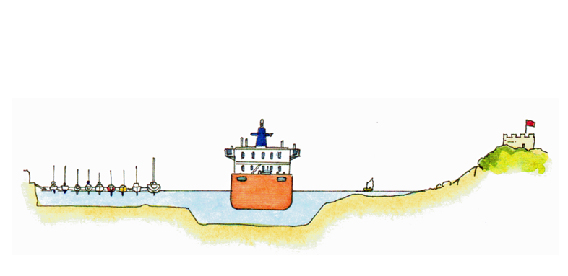

When is narrow, narrow?
It will depend on the sizes of the vessels involved and the available water.
A vessel travelling down a channel, half a mile wide, would probably not consider itself to be in a narrow channel. If a ship were to travel along the channel at the same time, the vessel would probably find the channel very narrow!
It is also common sense not to anchor in a narrow channel if this would cause a hazard to other traffic.
Small vessels should often travel along the sides of channels, buoyage is there for shipping and you maybe able to travel outside of the buoyed lane – but check water depth and tides first.
Additional discussion points:

