Session plan

Subject |  | IRPCS 18 Responsibilities between vessels

Session plan |  | Ref | SCC_CW06_SP_IRPCS18_RESONSIBILITIES_V00.00
Course |  | Chart work, Safety and distress [CW06]
Group/Award |  | Basic navigation 3rd Class
Aim |  | To ensure that cadets have knowledge of IRPCS 18
Training format |  | Individual or small team (2/3 people) activity
Duration |  | 30 minutes
References |  | SCC_CW06_SP_Safety and distress, IRPCS 18
Training aids |  | Vessel images cut outs (attached), scissors
Notes/Handouts |  | Question / Answer sheet (attached to session plan)  Optional: copy of Highway Code
Diversity |  | Support may need to be provided
Risk |  | Cutting out images

V00.00 | 03/09/16 | Initial draft

Session
Welcome |  | 5-minute introduction and discussion what cadets think the rule means to set the context. This could be put into the context of the highway code which cadets may be able to better visualise.
Activity #1 |  | 10-minute cadets to work on their own or in small teams to arrange the images in the order they believe should give way to other vessels.  Remind cadets that there is no “right of way” vessel – there is a “stand on” and “give way”.
Activity #2 |  | 10-minute cadets to give feedback why they have arranged the vessels in the order that they have.
Activity #3 |  | 5-minute instructor to explain the correct order and draw out from cadets why they believe the vessels are in the order they are. The logic is the hardest to manoeuvre has greater “stand-on” rights than those that can more easily manoeuvre.
Takeaway |  | The easier a vessel is to manoeuvre the more it has to respond to other vessels. The harder is it to manoeuvre the more the vessel will expect others to move out of its way. IRPCS08 says that if risk of collision all vessels should take action, even “stand-on”.
Consolidation |  | Session should be common sense if cadets think the logic through
Feedback

Lessons Learnt

​

IRPCS 18: Responsibilities between vessels
Rule 18: Responsibilities between vessels
Except where rules 9, 10, and 13 otherwise require:
(a) a power-driven vessel underway shall keep out of the way of:
(i) a vessel not under command.
(ii) a vessel restricted in her ability to manoeuvre.
(iii) a vessel engaged in fishing.
(iv) a sailing vessel.
(b) A sailing vessel underway shall keep out of the way of:
(i) a vessel not under command.
(ii) a vessel restricted in her ability to manoeuvre.
(iii) a vessel engaged in fishing.
(c) A vessel engaged in fishing when underway shall, so far as possible, keep out of the way of:
(i) a vessel not under command.
(ii) a vessel restricted in her ability to manoeuvre.
(d)
(i) Any vessel other than a vessel not under command or a vessel restricted in her ability to manoeuvre shall, if the circumstances of the case admit, avoid impeding the safe passage of a vessel constrained by her draught, exhibiting the signals in Rule 28.
(ii) A vessel constrained by her draught shall navigate with particular caution having full regard to her special condition.
(e) A seaplane on the water shall, in general, keep well clear of all vessels and avoid impeding their navigation. In circumstances, however, where risk of collision exists, she shall comply with the Rules of this Part.
(f)
(i) A WIG craft, when taking off, landing and in flight near the surface, shall keep well clear of all other vessels and avoid impeding their navigation.
(ii) a WIG craft operating on the water surface shall comply with the Rules of this Part as a power-driven vessel.
This is a fairly complicated and complex rule, but with a little prompting cadets should be able to gets most of the priorities correct.

Activity: shuffle
It is suggested that this rule is best taught by providing cadets with a range of images/pictures of different types of marine vessels and they are asked to place them in order of priority, then discuss why they have put them in that order.
Note: WIG craft Wing in Ground Effect crafts (WIG) are an emerging technology that provide transportation over water, with characteristics in between aircrafts and marine crafts.

Cut out images on stiff card to make for cadets to place in order or priority
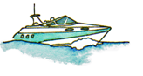 | 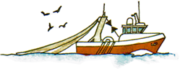
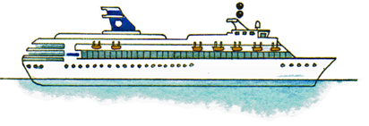 | 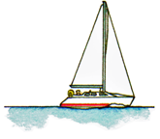
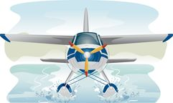 | 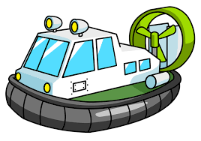
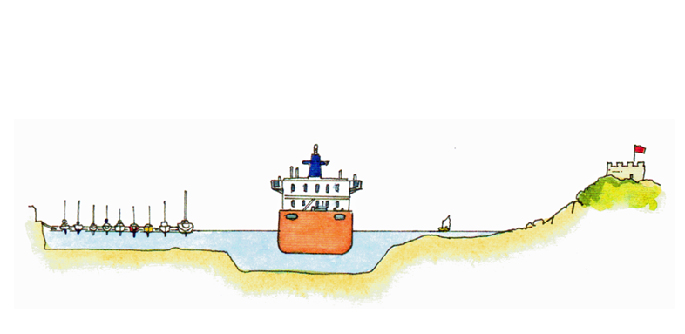 | 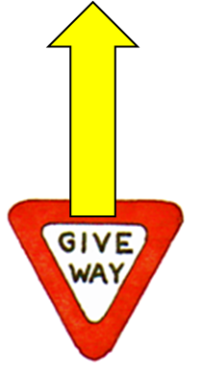
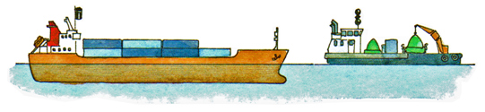

IRPCS: 18 responsibilities between vessels

