Session plan

Subject |  | IRPCS 19 Restricted visibility

Session plan |  | Ref | SCC_CW06_SP_IRPCS19_Visibility_v00.00
Course |  | Chart work, Safety and distress [CW06]
Group/Award |  | Basic navigation 3rd Class
Aim |  | To ensure that cadets have knowledge of IRPCS 19
Training format |  | Group, round-table, discussion or white board session  Consolidation questions, Page 4
Duration |  | 15 minutes
References
Training aids |  | n/a
Notes/Handouts
Diversity |  | Open discussion to ensure that all cadets have an opportunity to contribute
Risk |  | None

V00.00 | 25/09/16 | Initial draft

Session
Welcome |  | 1-minute introduction and discussion what cadets think the rule means to set simple introduction to the rule, this should not be overly long “What should vessels do when there is, or could be, reduced visibility?”
Activity #1 |  | 10-minute discussion with the leader posing the questions and cadets having an open discussion. Instructor to steer, using open questions, to draw out the answers.  Alternate write “poor visibility” in the centre of a white board and discuss situations when there could be poor visibility. Then discuss how to mitigate the risks.
Activity #2 |  | 4-minute summary  - Avoid if possible – weather forecast, stop, safe haven  - Look-out (all means)  - Safe speed  - Avoiding action
Takeaway |  | Safe  Speed – safe speed  Action - lookout  F  Evade – take avoiding action
Consolidation |  | Open question to draw out quick summary of the action to be taken
Feedback

Lessons Learnt

IRPCS 19: Restricted visibility
Rule 19: Conduct of vessels in restricted visibility
(a) This rule applies to vessels not in sight of one another when navigating in or near an area of restricted visibility.
(b) Every vessel shall proceed at a safe speed adapted to the prevailing circumstances and conditions of restricted visibility. A power-driven vessel shall have her engines ready for immediate manoeuvre.
(c) Every vessel shall have due regard to the prevailing circumstances and conditions of restricted visibility when complying with the Rules of Section I of this Part.
(d) A vessel which detects by radar alone the presence of another vessel shall determine if a close-quarters situation is developing and/or risk of collision exists. If so, she shall take avoiding action in ample time, provided that when such action consists of an alteration of course, so far as possible the following shall be avoided:
(i) an alteration of course to port for a vessel forwards of the beam, other than for a vessel being overtaken.
(ii) an alteration of course towards a vessel abeam or abaft the beam.
(e) Except where it has been determined that a risk of collision does not exist, every vessel which hears apparently forwards of her beam the fog signal of another vessel, or which cannot avoid a close-quarters situation with another vessel forwards of her beam, shall reduce her speed to the minimum at which she can be kept on her course. She shall if necessary take all her way off and in any event navigate with extreme caution until danger of collision is over.
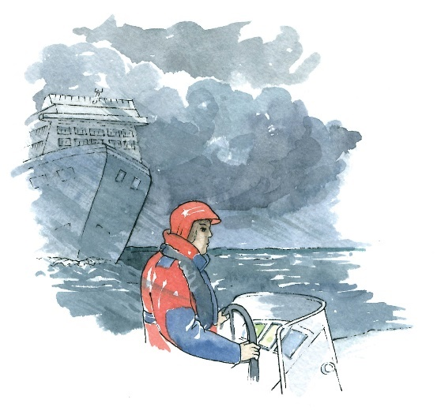
This rule is fairly common sense and cadets, with a little open questioning, should be able to identify the situations when this rule applies and what action needs to be taken. Teaching this session has therefore been based on a questioning strategy.

Activity: discussion (Session Plan page 1)
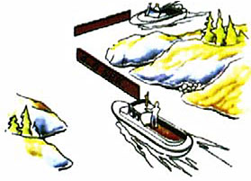
It is suggested that this rule is best taught through an open discussion, a range of example questions (and answers) are contained in the associated session plan.

Question/Answer: IRPCS: 19 restricted visibility
What is restricted visibility?
if vessels can see each other, which rules apply?
When may vessels not be able to see each other?
When else does this rule apply?
what is safe speed?
Can you really define what is a safe speed?
What rules apply when in restricted visibility?
What else needs to be done?
What else should you consider?

/Answer: IRPCS: 19 restricted visibility
 | What is restricted visibility? | Vessels can’t see, visually, each other.  If vessels can’t be seen or heard.  Seeing a vessel on a RADAR, for example, does not count as seeing is visually
 | if vessels can see each other, which rules apply? | Section 1. conduct of vessels in any condition of visibility (rules 4-10)  Section ii. conduct of vessels in sight of one another (rules 11-18)
 | When may vessels not be able to see each other? | Bad weather  Fog  Night (especially if moon obscured)  Headlands, islands  Bends in rivers and seaways  Anytime when one vessel cannot see the other visually (seeing on RADAR etc is excluded)
 | When else does this rule apply? | part (a) includes near an area of restricted visibility, for example near a fog bank
 | what is safe speed?  Can you really define what is a safe speed? | Depends on the conditions, vessel, traffic density, competency of the crew, types of boats likely to be in the area (e.g. fishing, trawling), pilots nearby
 | What rules apply when in restricted visibility? | Maintain a proper look-out (rule 5)  Proceed at safe speed (rule 6)  Use all available means to determine the riskof collision (rule 7)  Take proper avoiding action (rule 8)  Use RADAR correctly (rule 7b)  Navigate with caution in narrow channels and traffic separation schemes (rule 9 and 10)
 | What else needs to be done? | PART C. LIGHTS AND SHAPES  PART D - SOUND AND LIGHT SIGNALS
 | What else should you consider? | Check the weather before your set off  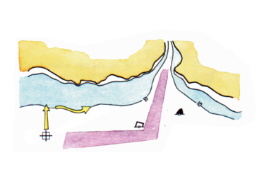  Find safe haven and anchor  Use your RADAR and any other electronic navigation tools  If you can’t see to navigate  - STOP  - Follow a depth level

