RMCD

Seamanship Training Syllabus

all modules

Reference Material
RMCD Training
SCC Website

SCC_RMCD_SP_Seamanship_V00.01
V00.00 | 27/12/16 | Initial document produced. Page 10 amended, in revision mode, 01/01/17
V00.01 | 16/01/17 | Navigation requirements removed as not part of Seamanship SM01-SM18

Contents
Contents 2
RMC Cadet Training Syllabus: Seamanship 3
Royal Marines Cadet promotion to Royal Marines Cadet Second Class 3
Royal Marines Cadet Second Class Promotion to Royal Marines Cadet First Class and Lance Corporal 3
Royal Marines Cadet First Class Promotion to Royal Marines Cadet Corporal 4
Cadet Corporal Promotion to Cadet Sergeant 5
Outline RMCD Seamanship course 6
MC3: Seamanship Third Class 7
The Role 7
Training 8
Eligibility 8
Assessment Criteria 8
Requirements 8
Dinghy Course Structure 8
Sheffield Sea Cadet Approach 9
Important Note 9
Seamanship Room Basic Requirements 10

RMC Cadet Training Syllabus: Seamanship
Seamanship skills appear in several RMCD training modules, these are:

Royal Marines Cadet promotion to Royal Marines Cadet Second Class
Description | Instructor's Reference | Sheffield Training Reference
R4 - Basic Seamanship  Parts of a ship:  Describe:  Stern, Aft, Midships, Bow, Forecastle, Port & Starboard, Hull, etc. Bends and Hitches:  Demonstrate and explain the use of: Reef Knot, Figure of Eight, Round Turn & Two Half Hitches. | Sea Cadets Seamanship Manual | SM01  SM02

Royal Marines Cadet Second Class Promotion to Royal Marines Cadet First Class and Lance Corporal
Description | Instructor's Reference | Sheffield Training Reference
MC3 - Seamanship  Qualify in Seamanship at 3rd Class. |  | Annex: SM01-SM18 Seamanship

Royal Marines Cadet First Class Promotion to Royal Marines Cadet Corporal
Description | Instructor's Reference
CP4 - Intermediate Boat work and Seamanship  Conduct:  Practical revision of all instructional given in Phase two.  Teach:  The Principle of the Block and Tackle (Demonstration).  The names of the various types of Tackle and the common uses for them.  Rigging Sheerlegs’ (Demonstration).  A Practical Exercise for using one or more of the above for the purpose of bringing a casualty on a stretcher down a steep incline and couple the exercise with practical First Aid Revision. The casualty in the exercise is to be a dummy.  Achieve a Competent Crew Rowing qualification. | Sea Cadets  Manual of  Seamanship  SCC Qualified  Seamanship  Instructors  SCC Rowing Log | SM05, SM12, SM18  SM11, SM17  SM11  TBC  TBC  TBC
CP11 - Knots and Splices  General revision of all instruction in Phases 1 & 2.  Teach and explain the application of the following knots and splices:  Bowline on the bight  Back splice  Timber Hitch |  | SM05, SM12, SM18  SM13, SM18 + bends/hitches handbook  Bends/hitches handbook  SM13, SM18 + bends/hitches handbook

Cadet Corporal Promotion to Cadet Sergeant
Description | Instructor's Reference | Sheffield Training Reference
SG4 - Advanced Boat work and Seamanship  Conduct:  Practical revision and tests of all instruction given in Phase Three.  Teach:  Introduction to practical boat work (Power and Sail). | Sea Cadet Seamanship  Manual | SM05, SM12, SM18  RYA Assistant Instructor Qualification (see Annex)
Note: RYA Assistant Instructor is probably a greater level of qualification than the RMCD expects, however, RYA AI would be a significant benefit to the boating station and as peer-educator. As a skill progression, it could also be considered for DoE.

Outline RMCD Seamanship course
Ref | Title | Content | Duration | MC2 | MC1 | Cdt Cpl | Cdt Sgt
SM01 | General Sea Terms | Parts of a Ship | 00:30 |  | 
SM02 | Bends and Hitches 1 | Reef knot, figure of eight, round turn and two half hitches | 00:30 |  | 
SM03 | Bends and Hitches 2 | Sheet bend, bowline, clove hitch | 00:45 |  | 
SM04 | General Ropework | Safety, coiling, cheesing, faking | 00:30 |  | 
SM05 | Consolidation Session | SM01, SM02, SM03, SM04 | 00:45 |  |  |  | 
SM06 | Bends and Hitches | Sheet bend, double sheet bend, clove hitch, rolling hitch | 00:30 |  | 
SM07 | Bends and Hitches 1 | Bowline, running bowline | 00:30 |  | 
SM08 | General Ropework | Natural fibre cordage (NFC) | 01:00 |  | 
SM09 | General Ropework | NFC and Man-Made Fibre Cordage (MMFC) | 00:30 |  | 
SM10 | General Rigging | Belaying | 00:30 |  | 
SM11 | General Rigging | Blocks | 00:30 |  |  | 
SM12 | Consolidation Session | SM06, SM07, SM08, SM09, SM10, SM11 | 00:30 |  |  |  | 
SM13 | Bends and Hitches | Timber hitch, fisherman’s bend, bowline, bowline on a bight | 00:45 |  |  | 
SM14 | General Ropework | Monkey’s Fist | 01:00 |  | 
SM15 | General Ropework | Heaving line, heaving line knot | 01:00 |  | 
SM16 | General Rigging | Tackle (2 x single block) | 01:00 |  | 
SM17 | General Rigging | Rigging terms and Orders | 00:30 |  |  | 
SM18 | Consolidation Session | SM13, SM14, SM15, SM16, SM17 | 00:45 |  |  |  | 
TBC | Rigging | Sheerlegs’ | 01:00 |  |  | 
TBC | Rigging | Lower a stretcher | 02:00 |  |  | 
TBC | Waterborne | Achieve Rowing Competent Crew | Courses |  |  |  | 
TBC | Waterborne | RYA Assistant Instructor | Courses |  |  |  | 
TBC | Boat work | Teach introduction to boat work (sail/power) | TBC |  |  |  | 
*indicates part of module and not full module

MC3: Seamanship Third Class
Seamanship Third Class consisted of 4 rigging and ropework tasks and 6 chartwork tasks. The Rigging and Ropework is covered by modules SM01 – SM18 (SM01/SM02 covered during R4), as follows all of which have lesson plans and detailed teaching instructions (can be found at http://www.chamberssailing.org/Pages/SeaCadets.aspx)
Ref | Title | Content
SM01 | General Sea Terms | Parts of a Ship
SM02 | Bends and Hitches 1 | Reef knot, figure of eight, round turn and two half hitches
SM03 | Bends and Hitches 2 | Sheet bend, bowline, clove hitch
SM04 | General Ropework | Safety, coiling, cheesing, faking
SM05 | Consolidation Session | SM01, SM02, SM03, SM04
SM06 | Bends and Hitches | Sheet bend, double sheet bend, clove hitch, rolling hitch
SM07 | Bends and Hitches 1 | Bowline, running bowline
SM08 | General Ropework | Natural fibre cordage (NFC)
SM09 | General Ropework | NFC and Man-Made Fibre Cordage (MMFC)
SM10 | General Rigging | Belaying
SM11 | General Rigging | Blocks
SM12 | Consolidation Session | SM06, SM07, SM08, SM09, SM10, SM11
SM13 | Bends and Hitches | Timber hitch, fisherman’s bend, bowline, bowline on a bight
SM14 | General Ropework | Monkey’s Fist
SM15 | General Ropework | Heaving line, heaving line knot
SM16 | General Rigging | Tackle (2 x single block)
SM17 | General Rigging | Rigging terms and Orders
SM18 | Consolidation Session | SM13, SM14, SM15, SM16, SM17

SG4: RYA Assistant Instructor Training

The Role
The role of the Assistant Instructor [AI] is to assist qualified instructors to teach beginners courses.
A Dinghy AI may teach up to and including Level 2 - Basic Skills in the National Sailing Scheme and Stage 3 of the Youth Sailing Scheme.
The training is relevant to any individual interested in encouraging children and adults to learn to sail. AIs should work under the supervision of an RYA Senior Instructor, helping qualified Instructors in the early stages of a groups learning. The AI will work under direct supervision always.
Within the Dinghy Scheme, Al's may act as helmsmen in the early stages, encouraging the students to take over as soon as possible. When teaching single handers, their role may often be that of a helper, rigger, catcher etc.

Training
- The training and assessment are conducted by the Principal or Chief Instructor who holds a valid RYA Senior Instructor Certificate;
- It will cover the teaching points related to beginners as detailed in the course content and assessment criteria;
- The training should last between 20 - 25 hours and may be given as a specific Assistant Instructor Course or may be provided on a one-to-one basis over a longer period as on the job training; and
- Most the time should be spent on the water covering how to put across the various teaching points for each session as laid out in the G 14 Dinghy Coaching Handbook.

Eligibility
Dinghy Assistant Instructor: Candidates must hold one of the National Sailing Scheme advanced modules.

Assessment Criteria
Following the training students will be assessed on their practical ability with beginners. Successful candidates should be issued with a certificate, their logbook signed and training given recorded.
The Al award is valid only at that centre, and for five years. As part of the centre's staff training programme, all assistants should be encouraged to gain RYA Instructor qualifications. If this is not possible, the Principal may re-issue an Al certificate.

Requirements
can:
- Sail a triangular course
- Pick up a mooring
- Coming alongside
- Reefing afloat
- Sailing backwards
- Anchoring
- Heave to
- Rudderless/centreboard-less sailing
- Rules of the road

Dinghy Course Structure
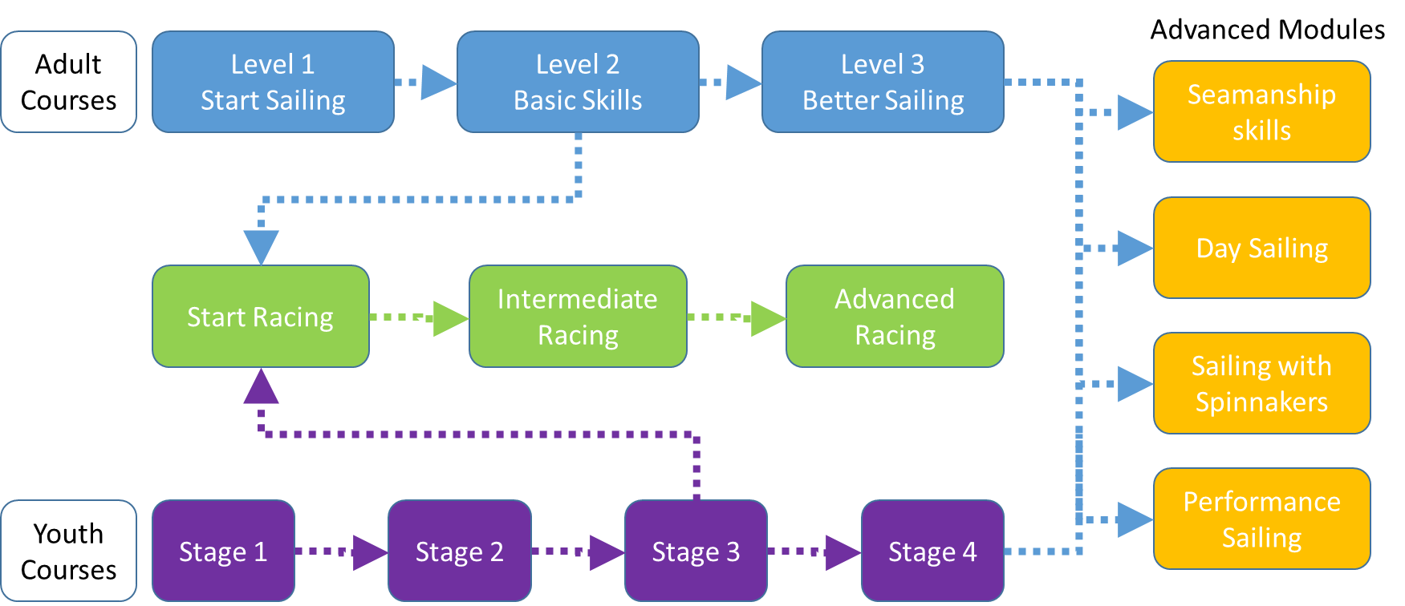

Sheffield Sea Cadet Approach
Within Sheffield Sea Cadet the preferred approach is to gain Seamanship Skills as the RYA advanced module. This includes:
Seamanship Skills | How to handle a boat in all circumstances and solve problems afloat
Assumed knowledge | Sailing skills to the standard of the Level 2 course
Minimum duration | 2 days (16 hours)
Course content | Launching and recovering the boat in different circumstances, stopping, reducing sail, recovering a man overboard, anchoring
Ability after course | Able to handle a wide range of situations afloat

Important Note
As the training and assessment is limited to the role of assisting qualified instructors and does not include first aid or powerboat handling, Assistant Instructors must never be allowed to work without direct supervision.
It is normal practice for every Principal to ensure that all his/her staff are conversant with the teaching techniques and local operating procedures of that centre. Thus, if an Assistant Instructor moves from one training centre to another, it is likely that their new Principal will issue a new Assistant Instructor Award after retraining.

Seamanship Room Basic Requirements
- Ropes (various lengths including long for heaving line)
- Blocks (various)
- Eye in ceiling for block demonstration
- Whiteboard, pens, rubber
- Noticeboards (for posters)
- Table (take A0 charts)
- Spar (preferable moveable) for knot practice
- Knotting display board (senior cadet project)
- Different types of ropes (natural fibre cordage) – small 6” example
- Cleat (attached to wall)
- Belaying pin (bracket attached to wall)
- Facility for PowerPoint presentations
- Outside
  - Sheer Legs
  - Ropes
  - Pulleys
  - Stretcher

