seamanship

SM10

General rigging

belay and cleat

Reference Material

|  |  |
| --- | --- |
| Rope | Suitable rope for cadets |
| Other | Belaying pin and cleat to demonstrate |

|  |  |  |
| --- | --- | --- |
| SCC\_SM10\_SP\_Belay\_V00.00 | | |
| V00.00 | 22/09/16 | Initial draft |

# Belay – Consolidation questions / Quiz

|  |  |
| --- | --- |
| Why do we belay to a cleat or pin? | Used when a rope must be able to be cast off quickly whilst under strain  Temporary only |
| Describe how we belay to a cleat | To belay to a cleat, take the initial turns as shaft of the cleat, then continue with figure-of eight turns around the horns as many times as required. Do not add a locking turn. |
| Describe how we belay to a pin | The best way to remember how to belay a line is to think of a belaying pin as having two sides, a fair side and a foul side. The fair side might be the left side of the pin or it might be the right side of the pin. Which side is fair depends on which side the line is coming from. If the line is coming from the right, then fair is on the right side and vice versa. You always start on the fair side, then you stay on the foul side. If you are coming from above the belaying pin, you should start your turns on the fair side below the belaying pin. If you are coming from below the belaying pin, you should start your turns on the fair side on the top of the belaying pin. |
| Give an example of belaying to a cleat or pin | Holding a sail  Holding a boat to a dock |

# http://2.bp.blogspot.com/-CfkKU9AY9Es/VAUZyhtiIKI/AAAAAAAABpc/QHRiUEDr2qs/s1600/1.%2BMorgan.jpgBelaying

“**Belay** means “stop.”  On a sailing ship, **belaying pins** were devices set along the railings (often in racks) where ropes were tied off. The pins were removable, which made it easier to lose the ropes in a hurry. You don’t always **belay** to a pin it could be to other things like a staghorn, cleat, single or double bollard.

A **belay** is used when a rope will have to be cast off while still under strain, it cannot be secured with a bend or hitch, except perhaps a slipping one.

It is therefore **belayed** to a fitting for the purpose, such as a cleat, staghorn or bollard. The action of belaying consists of taking sufficient turns around the fitting to hold the rope by friction when it takes the strain. Generally speaking, four complete turns should be sufficient, but the number of turns may have to be increased according to the degree of friction existing between rope and fitting. A wet and slippery rope or bollard, or a smooth cleat or staghorn and a well-worn rope may require extra turns.

To **belay** to a cleat or staghorn, take the initial turns as shown in the diagram below, then continue with figure-of eight turns around the horns as many times as required. A rope belayed to a cleat or staghorn must be ready for casting off at a moment's notice; therefore, the turns should not be completed with a half hitch because this may jam them. Cleats are not suitable for belaying wire rope.



## Belaying to a Cleat – “OXO”

One of the most common knots used for belaying to the cleat is called “cleat hitch” or often this is referred to as the “OXO” knot representing the way that you tie it.

To tie the belay, you go around the stock of the cleat (“O”), cross the cleat (“X”) and the around the stock again (“O”). For a temporary belay you do not put a locking turn on the belay.

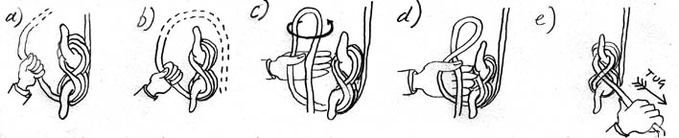If the belay is left as an “OXO” and strain is put on and taken of the knot can slip and work undone. To fix this problem a locking twist over a cleat horn is added – this is known a **Cleat Hitch**.

**Note:** The RYA tend to include a locking turn, Sea Cadets do not advocate the locking turn.

## Belaying to a pin

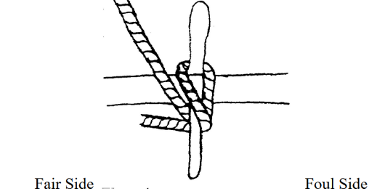The best way to remember how to belay a line is to think of a belaying pin as having two sides, a fair side and a foul side. The fair side might be the left side of the pin or it might be the right side of the pin. Which side is fair depends on which side the line is coming from. If the line is coming from the right, then fair is on the right side and vice versa. You always start on the fair side, then you stay on the foul side. If you are coming from above the belaying pin, you should start your turns on the fair side below the belaying pin. If you are coming from below the belaying pin, you should start your turns on the fair side on the top of the belaying pin.

In this case (above right), the fair side is on the left because the line is coming from the left. You will start on the bottom of the belaying pin because the line is coming from above.

You will start on the fair side, but all of your turns afterward will go on the foul side.

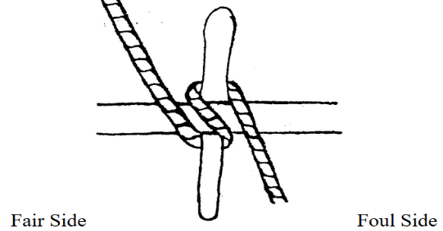

**This picture is wrong.** The line starts on the fair side, but then goes back up on the fair side. You should always start on the fair side, but then always go on the foul side until the belay is complete.

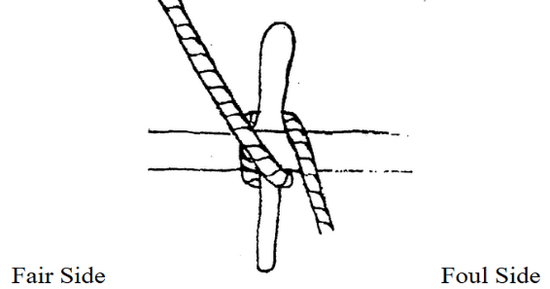**This picture is also wrong.** This is called a foul lead. Notice that it crosses in front of the pin *to the foul side* before it goes under.

## Belaying to Bollards

The belay is (i) and (ii) and (iii) adds a temporary lock to help take the strain



## Belaying to Twin Bollards



# Hanging a Coil on a Belaying Pin or a Cleat

**Hanging a Coil on a Belaying Pin or a Cleat** When belaying a rope to a Belaying pin the turns should be taken in the same way as for belaying to a cleat.

Whenever possible a coil should be hung up clear of the deck so as to keep the deck clear and the rope dry.



# “Bely that” (saying)

*Belay that:* In the (highly unlikely) event that a captain changes his mind and decides to rescind his last order by saying, “Belay that,” he is harkening back to the days when a “belaying” pin was used to hold a line fast (in its last position) on deck.

## Belay: Demonstration Board

Rack of belay pins and cleat to show and allow demonstration of Belaying

# C:\Users\Chamb\AppData\Local\Microsoft\Windows\INetCacheContent.Word\IMG_2921.jpg